**Assignment -1**

Python Programming

|  |  |
| --- | --- |
| Assignment Date | 19 September 2022 |
| Student Name | S.SUDHEEKSHAN KUMAR |
| Student Roll Number | 311519104703 |
| Maximum Marks | 2 Marks |

**Question-1:**

Create a registration page in html with username, email and phone number and by using post method display it in next html page.

**register.html**

<html>

<head>

<title>Registration page</title>

<link rel="stylesheet" href="{{url_for('static', filename='register.css')}}">

</head>

<body>

<div class="center"> <br /><br />

<form action="/register" method="POST">

<h1>Register</h1> <br /><br />

<p> Enter username:</p>

<input type="text" name= "username" />

<p> Enter email:</p>

<input type="email" name="email"/>

<p> Enter Phone number:</p>

<input type="text" name="phone"/>

</br></br></br>

<input type="submit" value="submit" />

</form>

</div>

</body>

</html>

**home.html**

<html>

<head>

<title>Home</title>

</head>

<body style="text-align:center">

<h2>Welcome {{username}} </h2><br/><br/>

<b>Username</b> - {{username}}<br/><br/>

<b>Email Address</b> - {{email}}<br/><br/>

<b>Phone number</b> - {{phone}}<br/><br/>

</body>

</html>

**Register.py**

from flask import Flask,render_template,request

app=Flask(__name__)

@app.route("/")

def home():

return render_template("register.html")

@app.route("/register",methods=["POST","GET"])

def register():

if request.method=="POST":

username=request.form.get('username')

email=request.form.get('email')

phone=request.form.get('phone')

return render_template("home.html",username=username,email=email,phone=phone)

if __name__ == '__main__':

app.run(debug=True)

**Output:**

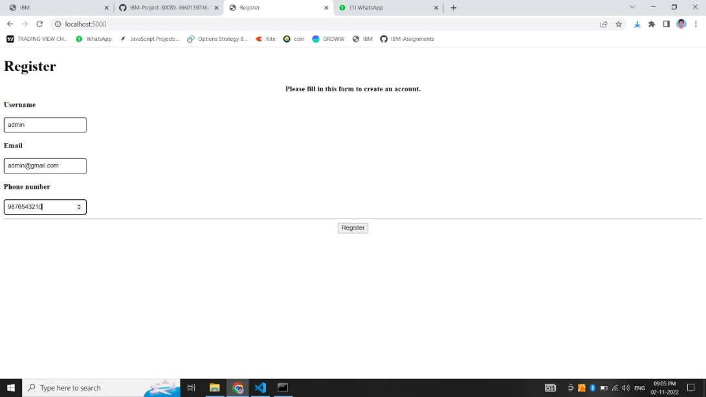

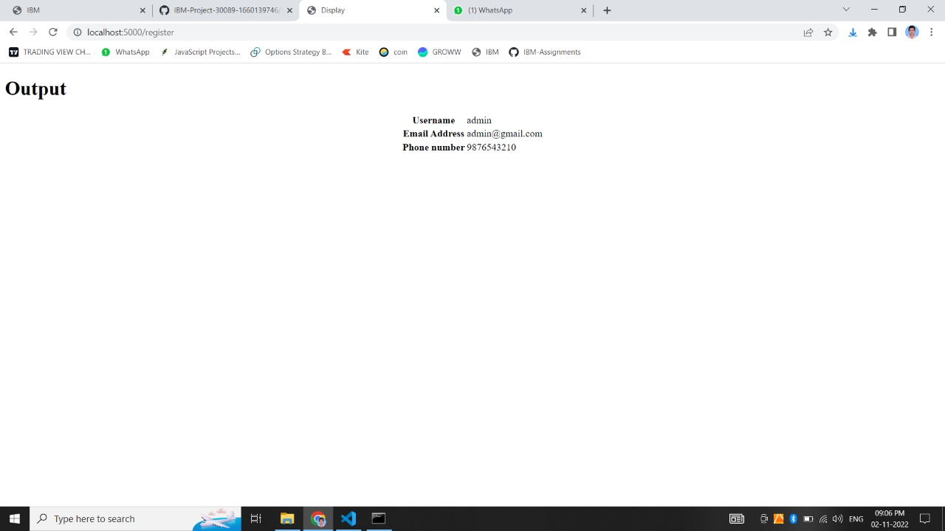

**Question-2:**

Develop a flask program which should I contain atleast 5 packages used from pypi.org.

**Packages used:**

1. render_template
2. url_for
3. redirect
4. request
5. abort

**Program :**

**python_packages.py**

from flask import Flask,render_template,request,redirect,url_for,abort

app=Flask(__name__)

@app.route("/")

def home():

return render_template("register.html")

@app.route("/register",methods=["POST","GET"])

def register():

if request.method=="POST":

username=request.form.get('username')

email=request.form.get('email')

phone=request.form.get('phone')

if username=="admin":

return redirect(url_for("admin_page"))

return render_template("home.html",username=username,email=email,phone=phone)

@app.route("/admin")

def admin_page():

return render_template("admin.html")

@app.route("/validate",methods=["POST","GET"])

def validate_admin():

if request.method=="POST":

password=request.form.get('password')

if(password=="abcd"):

return render_template("admindashboard.html")

else:

abort(403)

if __name__ == '__main__':

app.run(debug=True)

**register.html**

<html>

<head>

<title>Registration page</title>

<link rel="stylesheet" href="{{url_for('static', filename='register.css')}}">

</head>

<body>

<div class="center"> <br /><br />

<form action="/register" method="POST">

<h1>Register</h1> <br /><br />

<p> Enter username:</p>

<input type="text" name= "username" />

<p> Enter email:</p>

<input type="email" name="email"/>

<p> Enter Phone number:</p>

<input type="text" name="phone"/>

</br></br></br>

<input type="submit" value="submit" />

</form>

</div>

</body>

</html>

**home.html**

<!DOCTYPE html>

<html>

<head>

<title>Home</title>

</head>

<body style="text-align:center">

<h2>Welcome {{username}} </h2><br/><br/>

<b>Username</b> - {{username}}<br/><br/>

<b>Email Address</b> - {{email}}<br/><br/>

<b>Phone number</b> - {{phone}}<br/><br/>

</body>

</html>

**admin.html**

<html>

<head>

<title>Admin Login</title>

<link rel="stylesheet" href="{{url_for('static', filename='register.css')}}">

</head>

<body>

<div class="center"> <br /><br />

<form action="/validate" method="POST">

<h2 style="text-align:center">Admin login</h2> <br /><br />

<p> Enter password:</p>

<input type="text" name="password"/>

</br></br></br>

<input type="submit" value="submit" />

</form>

</div>

</body>

</html>

**admindashboard.html**

<html>

<head>

<title>Admin</title>

</head>

<body>

<h2 style="text-align:center">Welcome Administartor </h2><br/><br/>

<p><b>Who is an administrator?</b></p></br>

<p>Web administrators design, develop, maintain and troubleshoot websites. Most importantly, they ensure a safe and efficient user experience. This may include implementing security protocols, modifying programs, creating backups, resolving software problems, updating content and more. They may work with many clients or for one organization to design, program and monitor websites.Specific responsibilities include:</p>

<ul>

<li>Coding websites – the most popular languages include HTML and JavaScript</li>

<li>Collaborating with development teams to program websites</li>

<li>Setting up tools to monitor website traffic</li>

<li>Analyzing website traffic to inform design decisions</li>

</ul>

</body>

</html>

**Output:**

